

Transition Curriculum Guide
Low Incidence Disabilities

2016-2017

TABLE OF CONTENTS
Chapter 1: Transition Curriculum 4
Section 1.1: Occupational Skills Curriculum Overview guide 5
Subsection 1.1.A. Unit One: Daily Living 5
Subsection 1.1.B. Unit Two: Transportation/Mobility & Leisure 6
Subsection 1.1.C. Unit Three: Community Participation 7
Section 1.2: Social Curriculum Overview of Unit Guide 8
Subsection 1.2.A. Unit One: Abilities and Skills 8
Subsection 1.2.B. Unit Two: Self Advocacy by problem solving 9
Subsection 1.2.C. Unit Three: Understanding Social Situations 10
Subsection 1.2.D. Unit Four: Working with others 11
Subsection 1.2.E. Unit Five: Everyday Acceptable social behavior 12
Section 1.3: Career and Job Training Curriculum Overview Guide 13
Subsection 1.3.A. Unit One: Values, Interest and Preferences Inventories 13
Subsection 1.3.B. Unit Two: Career Exploration 14
Subsection 1.3.C. Unit Three: Getting a job 15
Subsection 1.3.C. Unit Four: Job Search and Securing 16

chapter 2: accommodations, Assessments and grading 17
Section 2.1. Level of rigor descriptor overview 18
Section 2.2. Level one 19
Subsection 2.2.A. Accommodations Examples 19
Subsection 2.2.B. Assessment Sample 20
Subsection 2.2.C. grading 21
Section 2.3. Level Two 24
Subsection 2.3.A. Accommodations Examples 24
Subsection 2.3.B. Assessment Sample 25
Subsection 2.3.C. grading 26
Section 2.4. Level Three 29
Subsection 2.4.A. Accommodations Examples 29
Subsection 2.4.B. Assessment Sample 30
Subsection 2.4.C. Grading 31
Section 2.5. Level Four 34
Subsection 2.5.A. Accommodations Examples 34
Subsection 2.5.B. Assessment Sample 35
Subsection 2.5.C. grading 36

Chapter 1
Transition Curriculum Overview Guides

Section 1.1: Occupational Curriculum Overview of Unit Guide
Section 1.1.A. Unit One: Daily Living
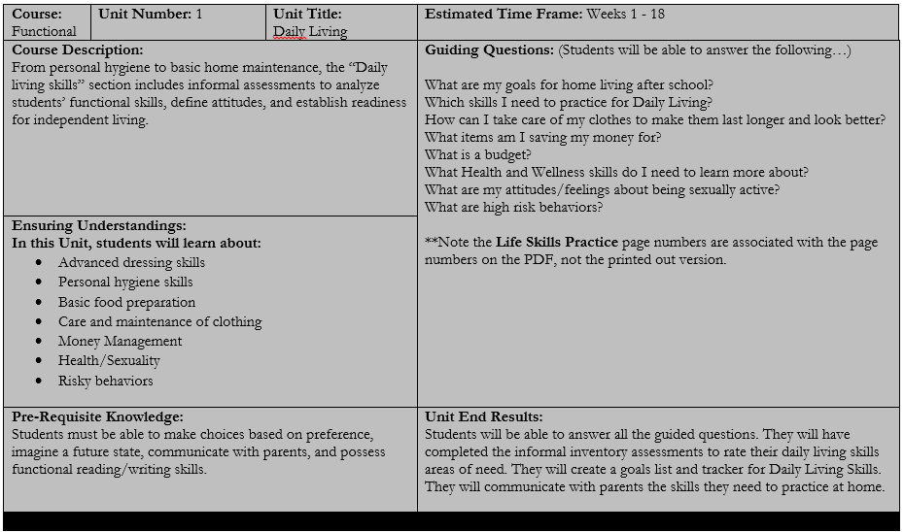

Section 1.1: Occupational Curriculum Overview of Unit Guide
Section 1.1.B. Unit Two: Transportation/Mobility & Leisure
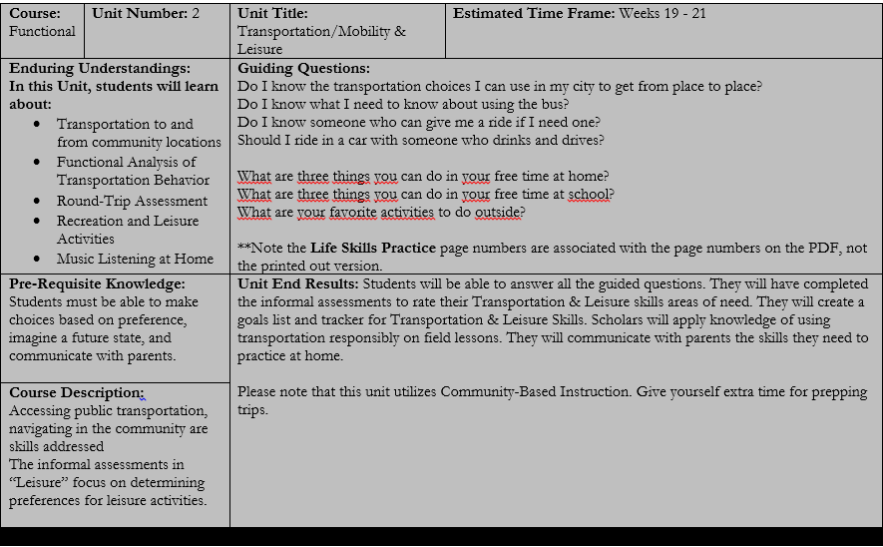

Section 1.1: Occupational Curriculum Overview of Unit Guide
Section 1.1.C. Unit Three: Community Participation
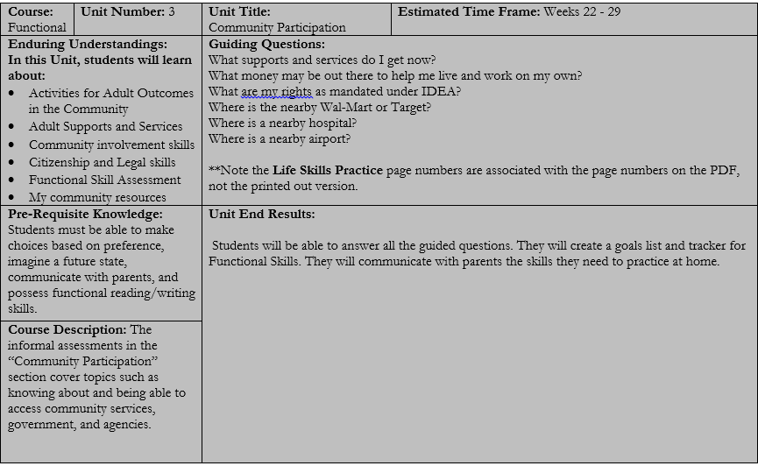

Section 1.2: Social Curriculum Overview of Unit Guide
Section 1.2.A. Unit One: Abilities and Skills
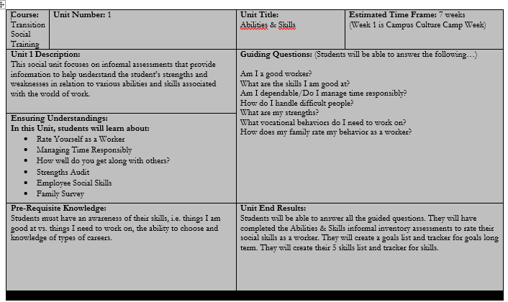

Section 1.2: Social Curriculum Overview of Unit Guide
Section 1.2.B. Unit Two: Self Advocacy by Problem Solving
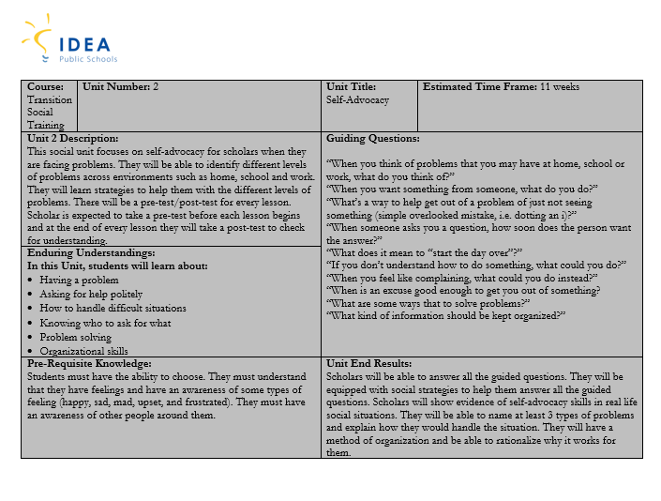

Section 1.2: Social Curriculum Overview of Unit Guide
Section 1.2.C. Unit Three: Understanding Social Situations
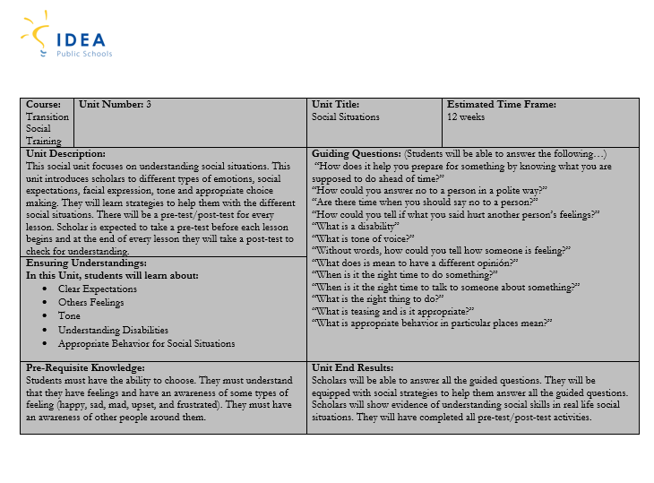

Section 1.2: Social Curriculum Overview of Unit Guide
Section 1.2.D. Unit Four: Working with Others
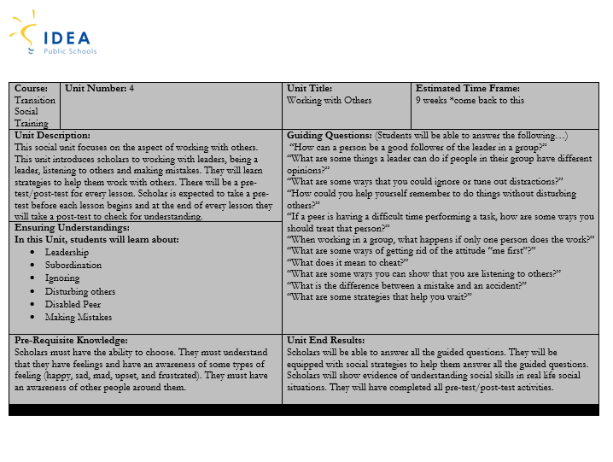

Section 1.2: Social Curriculum Overview of Unit Guide
Section 1.2.E. Unit Five: Everyday Acceptable Social Behavior
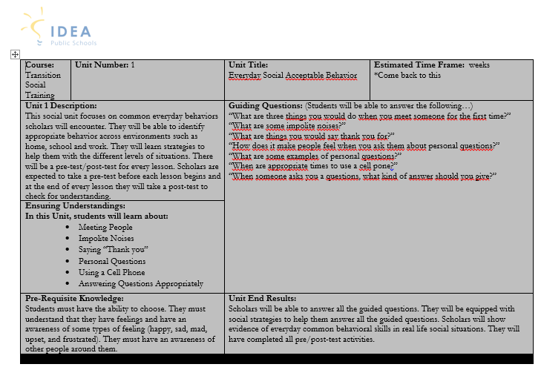

Section 1.3: Employment Curriculum Overview of Unit Guide
Section 1.3.A. Unit One: Values, interest and preferences Inventories
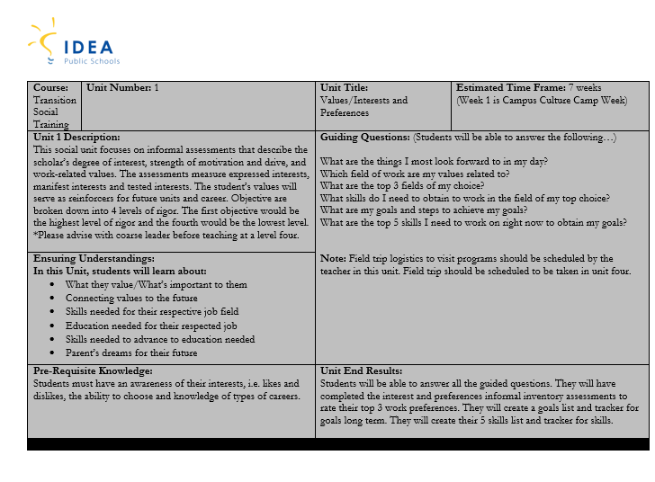

Section 1.3: Employment Curriculum Overview of Unit Guide
Section 1.3.B. Unit Two: Career Exploration
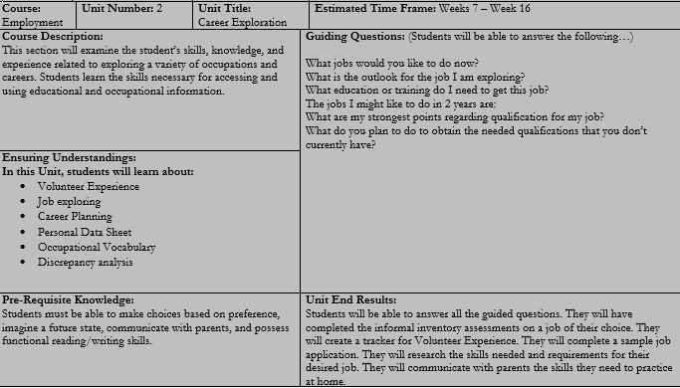

Section 1.3: Employment Curriculum Overview of Unit Guide
Section 1.3.C. Unit Three: Getting a Job
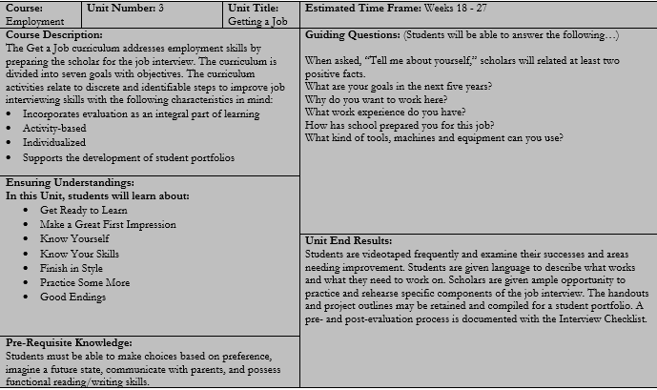

Section 1.3: Employment Curriculum Overview of Unit Guide
Section 1.3.D. Unit Four: Job Search and Securing
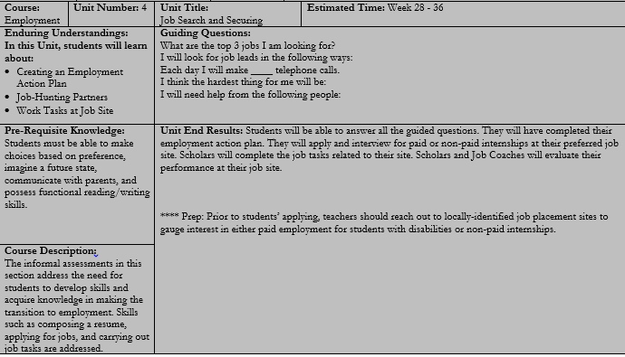

Chapter 2
Accommodations, Modifications, Assessments and Grading

Section 2.1. Level of Rigor Descriptor Overview
Level of Rigor | Descriptor | Assessment type | Grading Types
Level 1 | Scholar is able to read paragraphs and write complete sentences with grammatical errors. They have communication and functional skills. They are able to answer some higher order thinking questions. | Assessments with or without pictures. Multiple choice, true/false, short answer (with grammatical mistakes) quizzes, demonstration of skill and projects. | Answering correctly.  Writing rubrics.  Correct demonstration of skill the first time.  Project rubrics.
Level 2 | Scholar is able to read short sentences and write one-two word sentences with spelling errors. They have basic communication and functional skills. They are able to answer basic questions. | Assessments would have a combination of pictures with print. Multiple choice quizzes, and demonstration of skill. | Answering correctly.  Trial Tracking:  Demonstration of skill 4 out of 5 trials.
Level 3 | Scholar is able to distinguish pictures. They are able to communicate through pictures with the availability of choice making and may have some basic functional skills. They are able to answer basic questions when given choices through pictures. | Assessments would be picture-based and may include one word to label the picture. Discrete trials (demonstrations of skill). | Correct choice making.  Trial Tracking: Demonstration of skill 7 out of 10 trials.
Level 4 | Scholar may be able to distinguish some objects. They are able to communicate through crying or laughing. They have limited functional skills. They are able to participate when asked a direct question. People that know them well understand their subtle communication skills. | Assessments would include discrete trials of demonstration of skills. | Trial Tracking Demonstration of skill 7 out of 10 trials.

Section 2.2.A Level One Accommodations Examples
Curriculum Accommodations Sample
Week 19 | Scholars will identify plausible outcome or expectation when given a specific social situation. | - expectations  - clear  - social situation  - prepared  Vocab. Strategies  *word wall  *picture cards  *google search | - word processor  - board maker  - picture cards  - choice board  - picture situation cards (when this happens…do this)  - objects (level four) | Curriculum pages: 282-283  Social Skills Activities for Special Children by Darlene M.  Homework Assignments: Teacher can create an assignment to survey family on social functions their family normally attends. Scholars can practice strategies when in those situations.  Extension Activity: Teacher can create work-related scenario situations. Example: During break time at work, what is the expectation of the employees around the “water cooler”?  Assessment: Scholars will be given a Pre-test (page 283). Directions: give scholar the assessment before teaching (they will get a grade of 100% for participation). For their weekly assessment, scholars will be given a Post-test (page 283). Directions: give scholars post-test after all lessons and activities. The scoring will be based off of answers answered correctly. Note: All assessments are created for level one scholars. The assessment will need to be modified by the teacher if a scholar needs to be assessed at levels two-four.
Scope and Sequence: Transition Social Training
Accommodation one examples should be minimal. As the descriptor outlined, these scholars should be able to acquire the curriculum as it is written and designed. When preparing for a level one scholar, you will be able to use the curriculum assessments as they are written. If these scholars are still in need of accommodations, it would be in the form of motor development or visual perception. For example, a student may have poor mobility in their hands and have trouble with the writing portion of the assignment. It would be helpful to have the student type out the assignment or answers on a laptop or word processor. The curriculum will give suggestions of types of accommodations. However, please refer to the scholar’s IEP for more detailed accommodations they may need.
Section 2.2.B. Level One Assessment Sample
Curriculum Assessment Sample
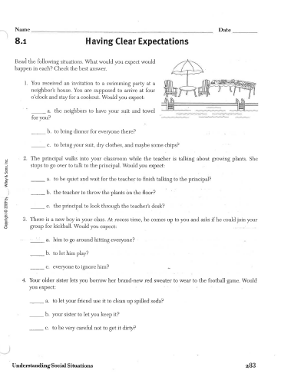
This is an example of an assessment type for a level one student that is built into the curriculum. This would be an appropriate assessment with no modifications needed for content.

Section 2.2.C. Level One Grading
Pre-Test (10%)
Pre-test are designed in the curriculum to assess a scholar’s knowledge before teaching begins and will serve as 10% of their overall grade in the gradebook. Scholars would take the assessment outlined in the scope and sequence. Teachers will only record a grade for learning purposes not for mastery purposes. All scholars that take the pre-test will receive a 100% participation grade for participating in the pre-test in the course gradebook.
Week 19 | Scholars will identify plausible outcome or expectation when given a specific social situation. | - expectations  - clear  - social situation  - prepared  Vocab. Strategies  *word wall  *picture cards  *google search | - word processor  - board maker  - picture cards  - choice board  - picture situation cards (when this happens…do this)  - objects (level four) | Curriculum pages: 282-283  Social Skills Activities for Special Children by Darlene M.  Homework Assignments: Teacher can create an assignment to survey family on social functions their family normally attends. Scholars can practice strategies when in those situations.  Extension Activity: Teacher can create work-related scenario situations. Example: During break time at work, what is the expectation of the employees around the “water cooler”?  Assessment: Scholars will be given a Pre-test (page 283). Directions: give scholar the assessment before teaching (they will get a grade of 100% for participation). For their weekly assessment, scholars will be given a Post-test (page 283). Directions: give scholars post-test after all lessons and activities. The scoring will be based off of answers answered correctly. Note: All assessments are created for level one scholars. The assessment will need to be modified by the teacher if a scholar needs to be assessed at levels two-four.
Scope and Sequence: Transition Social Training

Post-Test (10%)
Post-tests are designed to assess the scholar’s knowledge after teaching is complete. This assessment will serve as the scholar’s weekly assessment grade and will serve as 10% of the scholar’s overall grade in the gradebook. The Post-test’s content is the same as the Pre-test’s content and will be included in the scope and sequence. Post-tests will need to be graded as a percentage of right/total number of answers. For example, if a scholar made 1 error out of 10 questions (9/10=90) then they would receive 90% and that would be recorded in the Post-Test section of the gradebook.
Week 19 | Scholars will identify plausible outcome or expectation when given a specific social situation. | - expectations  - clear  - social situation  - prepared  Vocab. Strategies  *word wall  *picture cards  *google search | - word processor  - board maker  - picture cards  - choice board  - picture situation cards (when this happens…do this)  - objects (level four) | Curriculum pages: 282-283  Social Skills Activities for Special Children by Darlene M.  Homework Assignments: Teacher can create an assignment to survey family on social functions their family normally attends. Scholars can practice strategies when in those situations.  Extension Activity: Teacher can create work-related scenario situations. Example: During break time at work, what is the expectation of the employees around the “water cooler”?  Assessment: Scholars will be given a Pre-test (page 283). Directions: give scholar the assessment before teaching (they will get a grade of 100% for participation). For their weekly assessment, scholars will be given a Post-test (page 283). Directions: give scholars post-test after all lessons and activities. The scoring will be based off of answers answered correctly. Note: All assessments are created for level one scholars. The assessment will need to be modified by the teacher if a scholar needs to be assessed at levels two-four.
Scope and Sequence: Transition Social Training

Other Assignments (80%)
Other Assignments would consist of the activities or participation in assignments the teacher has created throughout the week or semester. These assignments are not included in the scope and sequence. They are teacher based. For example, in the sample below there is an extension activity. This activity would be made longer by the teacher or role played by the scholars. The teacher would either grade the paper assignment or based off a rubric for the role play. Scholars should be participating in a minimum of 1 assignment categorized as other assignments per week. This grade will be decided and categorized by the teacher in the gradebook as other assignments.
Week 19 | Scholars will identify plausible outcome or expectation when given a specific social situation. | - expectations  - clear  - social situation  - prepared  Vocab. Strategies  *word wall  *picture cards  *google search | - word processor  - board maker  - picture cards  - choice board  - picture situation cards (when this happens…do this)  - objects (level four) | Curriculum pages: 282-283  Social Skills Activities for Special Children by Darlene M.  Homework Assignments: Teacher can create an assignment to survey family on social functions their family normally attends. Scholars can practice strategies when in those situations.  Extension Activity: Teacher can create work-related scenario situations. Example: During break time at work, what is the expectation of the employees around the “water cooler”?  Assessment: Scholars will be given a Pre-test (page 283). Directions: give scholar the assessment before teaching (they will get a grade of 100% for participation). For their weekly assessment, scholars will be given a Post-test (page 283). Directions: give scholars post-test after all lessons and activities. The scoring will be based off of answers answered correctly. Note: All assessments are created for level one scholars. The assessment will need to be modified by the teacher if a scholar needs to be assessed at levels two-four.
Scope and Sequence: Transition Social Training

Section 2.2.A Level Two Accommodations Examples
Curriculum Accommodations Sample
Week 19 | Scholars will identify plausible outcome or expectation when given a specific social situation. | - expectations  - clear  - social situation  - prepared  Vocab. Strategies  *word wall  *picture cards  *google search | - word processor  - board maker  - picture cards  - choice board  - picture situation cards (when this happens…do this)  - objects (level four) | Curriculum pages: 282-283  Social Skills Activities for Special Children by Darlene M.  Homework Assignments: Teacher can create an assignment to survey family on social functions their family normally attends. Scholars can practice strategies when in those situations.  Extension Activity: Teacher can create work-related scenario situations. Example: During break time at work, what is the expectation of the employees around the “water cooler”?  Assessment: Scholars will be given a Pre-test (page 283). Directions: give scholar the assessment before teaching (they will get a grade of 100% for participation). For their weekly assessment, scholars will be given a Post-test (page 283). Directions: give scholars post-test after all lessons and activities. The scoring will be based off of answers answered correctly. Note: All assessments are created for level one scholars. The assessment will need to be modified by the teacher if a scholar needs to be assessed at levels two-four.
Scope and Sequence: Transition Social Training
As the descriptor outlined, these scholars should be able to acquire the curriculum with minimal accommodations such as picture aides or the teacher reading the text in order to extract meaning from the text. When preparing for a level two scholar, you will need to add to the curriculum assessments. The curriculum will give suggestions of types of accommodations. However, please refer to the scholar’s IEP for more detailed accommodations they may need.

Section 2.2.B. Level Two Assessment Sample
Curriculum Assessment Sample
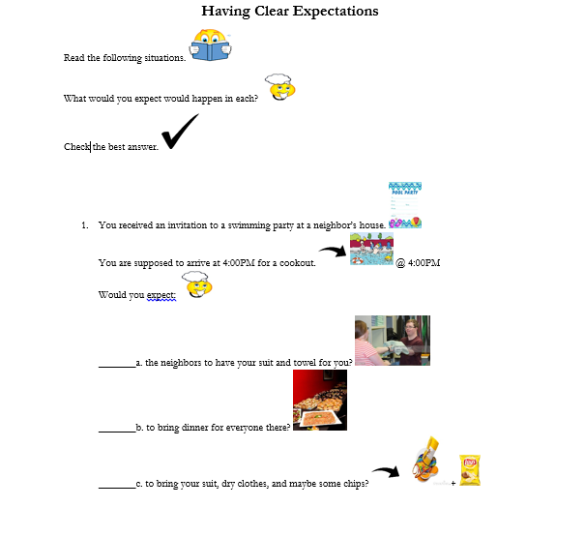
This is an example of an assessment type for a level two student that is teacher-made. This would be an appropriate assessment with no modifications needed for content. Teachers can create using picture software or a word document.

Section 2.2.C. Level Two Grading
Pre-Test (10%)
Pre-test are designed in the curriculum to assess a scholar’s knowledge before teaching begins and will serve as 10% of their overall grade in the gradebook. Scholars would take the assessment outlined in the scope and sequence. Teachers will only record a grade for learning purposes not for mastery purposes. All scholars that take the pre-test will receive a 100% participation grade for participating in the pre-test in the course gradebook.
Week 19 | Scholars will identify plausible outcome or expectation when given a specific social situation. | - expectations  - clear  - social situation  - prepared  Vocab. Strategies  *word wall  *picture cards  *google search | - word processor  - board maker  - picture cards  - choice board  - picture situation cards (when this happens…do this)  - objects (level four) | Curriculum pages: 282-283  Social Skills Activities for Special Children by Darlene M.  Homework Assignments: Teacher can create an assignment to survey family on social functions their family normally attends. Scholars can practice strategies when in those situations.  Extension Activity: Teacher can create work-related scenario situations. Example: During break time at work, what is the expectation of the employees around the “water cooler”?  Assessment: Scholars will be given a Pre-test (page 283). Directions: give scholar the assessment before teaching (they will get a grade of 100% for participation). For their weekly assessment, scholars will be given a Post-test (page 283). Directions: give scholars post-test after all lessons and activities. The scoring will be based off of answers answered correctly. Note: All assessments are created for level one scholars. The assessment will need to be modified by the teacher if a scholar needs to be assessed at levels two-four.
Scope and Sequence: Transition Social Training

Post-Test (10%)
Post-tests are designed to assess the scholar’s knowledge after teaching is complete. This assessment will serve as the scholar’s weekly assessment grade and will serve as 10% of the scholar’s overall grade in the gradebook. The Post-test’s content is the same as the Pre-test’s content and as outlined the scope and sequence. Post-tests will need to be graded as a percentage of right/total number of answers. For example, if a scholar made 1 error out of 10 questions (9/10=90) then they would receive 90% and that would be recorded in the Post-Test section of the gradebook.
Week 19 | Scholars will identify plausible outcome or expectation when given a specific social situation. | - expectations  - clear  - social situation  - prepared  Vocab. Strategies  *word wall  *picture cards  *google search | - word processor  - board maker  - picture cards  - choice board  - picture situation cards (when this happens…do this)  - objects (level four) | Curriculum pages: 282-283  Social Skills Activities for Special Children by Darlene M.  Homework Assignments: Teacher can create an assignment to survey family on social functions their family normally attends. Scholars can practice strategies when in those situations.  Extension Activity: Teacher can create work-related scenario situations. Example: During break time at work, what is the expectation of the employees around the “water cooler”?  Assessment: Scholars will be given a Pre-test (page 283). Directions: give scholar the assessment before teaching (they will get a grade of 100% for participation). For their weekly assessment, scholars will be given a Post-test (page 283). Directions: give scholars post-test after all lessons and activities. The scoring will be based off of answers answered correctly. Note: All assessments are created for level one scholars. The assessment will need to be modified by the teacher if a scholar needs to be assessed at levels two-four.
Scope and Sequence: Transition Social Training

Other Assignments (80%)
Other Assignments would consist of the activities or participation in assignments the teacher has created throughout the week or semester. These assignments are not included in the scope and sequence. They are teacher based. For example, in the sample below there is an extension activity. This activity would be made longer by the teacher or role played by the scholars. The teacher would either grade the paper assignment or based off a rubric for the role play. Scholars should be participating in a minimum of 1 assignment categorized as other assignments per week. This grade will be decided and categorized by the teacher in the gradebook as other assignments.
Week 19 | Scholars will identify plausible outcome or expectation when given a specific social situation. | - expectations  - clear  - social situation  - prepared  Vocab. Strategies  *word wall  *picture cards  *google search | - word processor  - board maker  - picture cards  - choice board  - picture situation cards (when this happens…do this)  - objects (level four) | Curriculum pages: 282-283  Social Skills Activities for Special Children by Darlene M.  Homework Assignments: Teacher can create an assignment to survey family on social functions their family normally attends. Scholars can practice strategies when in those situations.  Extension Activity: Teacher can create work-related scenario situations. Example: During break time at work, what is the expectation of the employees around the “water cooler”?  Assessment: Scholars will be given a Pre-test (page 283). Directions: give scholar the assessment before teaching (they will get a grade of 100% for participation). For their weekly assessment, scholars will be given a Post-test (page 283). Directions: give scholars post-test after all lessons and activities. The scoring will be based off of answers answered correctly. Note: All assessments are created for level one scholars. The assessment will need to be modified by the teacher if a scholar needs to be assessed at levels two-four.
Scope and Sequence: Transition Social Training

Section 2.4.A Level Three Modification Examples
Curriculum Modification Sample
Week 19 | Scholars will identify with a choice board a plausible outcome or expectation when given a specific social situation. | - expectations  - clear  - social situation  - prepared  Vocab. Strategies  *word wall  *picture cards  *google search | - word processor  - board maker  - picture cards  - choice board  - picture situation cards (when this happens…do this)  - objects (level four) | Curriculum pages: 282-283  Social Skills Activities for Special Children by Darlene M.  Homework Assignments: Teacher can create an assignment to survey family on social functions their family normally attends. Scholars can practice strategies when in those situations.  Extension Activity: Teacher can create work-related scenario situations. Example: During break time at work, what is the expectation of the employees around the “water cooler”?  Assessment: Scholars will be given a Pre-test (page 283). Directions: give scholar the assessment before teaching (they will get a grade of 100% for participation). For their weekly assessment, scholars will be given a Post-test (page 283). Directions: give scholars post-test after all lessons and activities. The scoring will be based off of answers answered correctly. Note: All assessments are created for level one scholars. The assessment will need to be modified by the teacher if a scholar needs to be assessed at levels two-four.
Scope and Sequence: Transition Social Training
Level three scholars would need modifications to help them acquire the curriculum. The assessment that is included in the curriculum would need to be modified for this level. When preparing for a level three scholar, you will need to base the assessment from the curriculum, but delivery will differ. Teachers may prep materials with a choice board or picture-based test with yes/no responses. Teacher could also present materials in isolation. The curriculum will give suggestions of types of accommodations that could be used. However, please refer to the scholar’s IEP for more detailed accommodations they may need.

Section 2.4.B. Level Three Assessment Sample
Curriculum Assessment Sample
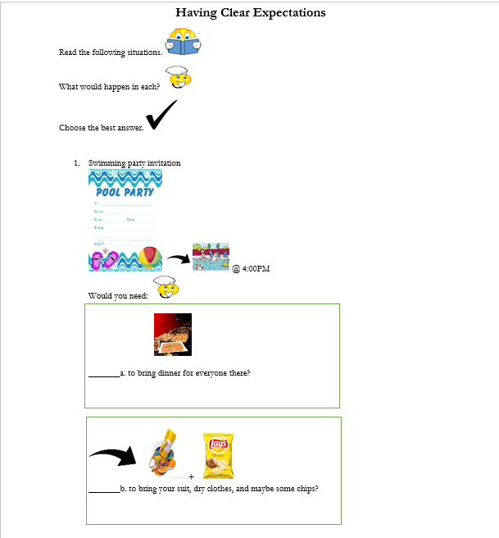
This is an example of an assessment type for a level three scholar that has been teacher-made. The content has been slightly modified from the level one assessment, pictures and additional spacing has been added. Teachers can create on a picture software program or a word document.

Section 2.3.C. Level Three Grading
Pre-Test (10%)
Pre-test are designed in the curriculum to assess a scholar’s knowledge before teaching begins and will serve as 10% of their overall grade in the gradebook. Scholars would take the assessment outlined in the scope and sequence. Teachers will only record a grade for learning purposes not for mastery purposes. All scholars that take the pre-test will receive a 100% participation grade for participating in the pre-test in the course gradebook.
Week 19 | Scholars will identify with a choice board a plausible outcome or expectation when given a specific social situation. | - expectations  - clear  - social situation  - prepared  Vocab. Strategies  *word wall  *picture cards  *google search | - word processor  - board maker  - picture cards  - choice board  - picture situation cards (when this happens…do this)  - objects (level four) | Curriculum pages: 282-283  Social Skills Activities for Special Children by Darlene M.  Homework Assignments: Teacher can create an assignment to survey family on social functions their family normally attends. Scholars can practice strategies when in those situations.  Extension Activity: Teacher can create work-related scenario situations. Example: During break time at work, what is the expectation of the employees around the “water cooler”?  Assessment: Scholars will be given a Pre-test (page 283). Directions: give scholar the assessment before teaching (they will get a grade of 100% for participation). For their weekly assessment, scholars will be given a Post-test (page 283). Directions: give scholars post-test after all lessons and activities. The scoring will be based off of answers answered correctly. Note: All assessments are created for level one scholars. The assessment will need to be modified by the teacher if a scholar needs to be assessed at levels two-four.
Scope and Sequence: Transition Social Training

Post-Test (10%)
Post-tests are designed to assess the scholar’s knowledge after teaching is complete. This assessment will serve as the scholar’s weekly assessment grade and will serve as 10% of the scholar’s overall grade in the gradebook. The Post-test’s content is the same as the Pre-test’s content and are outlined in the scope and sequence. Post-tests will need to be graded as a percentage of right/total number of answers. For example, if a scholar made 1 error out of 10 questions (9/10=90) then they would receive 90% and that would be recorded in the Post-Test section of the gradebook.
Week 19 | Scholars will identify with a choice board a plausible outcome or expectation when given a specific social situation. | - expectations  - clear  - social situation  - prepared  Vocab. Strategies  *word wall  *picture cards  *google search | - word processor  - board maker  - picture cards  - choice board  - picture situation cards (when this happens…do this)  - objects (level four) | Curriculum pages: 282-283  Social Skills Activities for Special Children by Darlene M.  Homework Assignments: Teacher can create an assignment to survey family on social functions their family normally attends. Scholars can practice strategies when in those situations.  Extension Activity: Teacher can create work-related scenario situations. Example: During break time at work, what is the expectation of the employees around the “water cooler”?  Assessment: Scholars will be given a Pre-test (page 283). Directions: give scholar the assessment before teaching (they will get a grade of 100% for participation). For their weekly assessment, scholars will be given a Post-test (page 283). Directions: give scholars post-test after all lessons and activities. The scoring will be based off of answers answered correctly. Note: All assessments are created for level one scholars. The assessment will need to be modified by the teacher if a scholar needs to be assessed at levels two-four.
Scope and Sequence: Transition Social Training

Other Assignments (80%)
Other Assignments would consist of the activities or participation in assignments the teacher has created throughout the week or semester. These assignments are not included in the scope and sequence. They are teacher based. For example, in the sample below there is an extension activity. This activity would be made longer by the teacher or role played by the scholars. The teacher would either grade the paper assignment or based off a rubric for the role play. Scholars should be participating in a minimum of 1 assignment categorized as other assignments per week. This grade will be decided and categorized by the teacher in the gradebook as other assignments.
Week 19 | Scholars will identify with a choice board a plausible outcome or expectation when given a specific social situation. | - expectations  - clear  - social situation  - prepared  Vocab. Strategies  *word wall  *picture cards  *google search | - word processor  - board maker  - picture cards  - choice board  - picture situation cards (when this happens…do this)  - objects (level four) | Curriculum pages: 282-283  Social Skills Activities for Special Children by Darlene M.  Homework Assignments: Teacher can create an assignment to survey family on social functions their family normally attends. Scholars can practice strategies when in those situations.  Extension Activity: Teacher can create work-related scenario situations. Example: During break time at work, what is the expectation of the employees around the “water cooler”?  Assessment: Scholars will be given a Pre-test (page 283). Directions: give scholar the assessment before teaching (they will get a grade of 100% for participation). For their weekly assessment, scholars will be given a Post-test (page 283). Directions: give scholars post-test after all lessons and activities. The scoring will be based off of answers answered correctly. Note: All assessments are created for level one scholars. The assessment will need to be modified by the teacher if a scholar needs to be assessed at levels two-four.
Scope and Sequence: Transition Social Training

Section 2.3.A Level Four Modification Examples
Curriculum Modification Sample
Week 19 | Scholars will demonstrate the expectation when given a specific social situation. | - expectations  - clear  - social situation  - prepared  Vocab. Strategies  *word wall  *picture cards  *google search | - word processor  - board maker  - picture cards  - choice board  - picture situation cards (when this happens…do this)  - objects (level four) | Curriculum pages: 282-283  Social Skills Activities for Special Children by Darlene M.  Homework Assignments: Teacher can create an assignment to survey family on social functions their family normally attends. Scholars can practice strategies when in those situations.  Extension Activity: Teacher can create work-related scenario situations. Example: During break time at work, what is the expectation of the employees around the “water cooler”?  Assessment: Scholars will be given a Pre-test (page 283). Directions: give scholar the assessment before teaching (they will get a grade of 100% for participation). For their weekly assessment, scholars will be given a Post-test (page 283). Directions: give scholars post-test after all lessons and activities. The scoring will be based off of answers answered correctly. Note: All assessments are created for level one scholars. The assessment will need to be modified by the teacher if a scholar needs to be assessed at levels two-four.
Scope and Sequence: Transition Social Training
Level four scholars would typically be scholars that require one-to-one assistance. As the descriptor outlined, these scholars would primarily access the curriculum through objects and demonstrations. When preparing for a level four scholar, you need to plan materials ahead of time. The curriculum will give suggestions of types of accommodations that could be used. However, please refer to the scholar’s IEP for more detailed accommodations they may need.

Section 2.3.B. Level Four Assessment Sample
Curriculum Assessment Sample
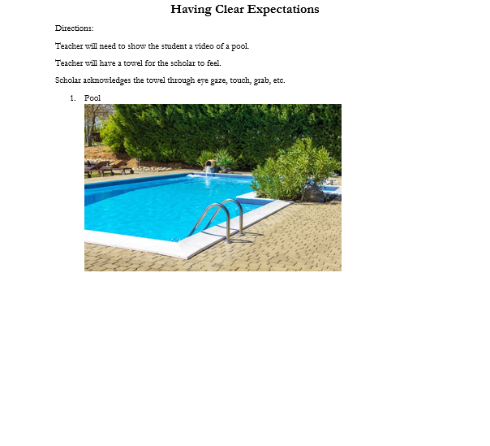
This is an example of an assessment type for a level four scholar that has been teacher-made. It contains has been modified in order for the scholar to access the curriculum. Teacher would need to acquire real objects and research videos that would be appropriate.

Section 2.3.C. Level Four Grading
Pre-Test (10%)
Pre-test are designed in the curriculum to assess a scholar’s knowledge before teaching begins and will serve as 10% of their overall grade in the gradebook. Scholars would take the assessment outlined in the scope and sequence. Teachers will only record a grade for learning purposes not for mastery purposes. All scholars that take the pre-test will receive a 100% participation grade for participating in the pre-test in the course gradebook.
Week 19 | Scholars will identify plausible outcome or expectation when given a specific social situation. | - expectations  - clear  - social situation  - prepared  Vocab. Strategies  *word wall  *picture cards  *google search | - word processor  - board maker  - picture cards  - choice board  - picture situation cards (when this happens…do this)  - object calendar schedule (level four) | Curriculum pages: 282-283  Social Skills Activities for Special Children by Darlene M.  Homework Assignments: Teacher can create an assignment to survey family on social functions their family normally attends. Scholars can practice strategies when in those situations.  Extension Activity: Teacher can create work-related scenario situations. Example: During break time at work, what is the expectation of the employees around the “water cooler”?  Assessment: Scholars will be given a Pre-test (page 283). Directions: give scholar the assessment before teaching (they will get a grade of 100% for participation). For their weekly assessment, scholars will be given a Post-test (page 283). Directions: give scholars post-test after all lessons and activities. The scoring will be based off of answers answered correctly. Note: All assessments are created for level one scholars. The assessment will need to be modified by the teacher if a scholar needs to be assessed at levels two-four.
Scope and Sequence: Transition Social Training

Post-Test (10%)
Post-tests are designed to assess the scholar’s knowledge after teaching is complete. This assessment will serve as the scholar’s weekly assessment grade and will serve as 10% of the scholar’s overall grade in the gradebook. The Post-test’s content is the same as the Pre-test’s content and will be outlined the scope and sequence. Post-tests will graded based off of participation for level four scholars. The grade will be based off of participation level. However, if more practice on the skill is needed, then the teacher may choose to revisit skill until mastery.
Week 19 | Scholars will identify plausible outcome or expectation when given a specific social situation. | - expectations  - clear  - social situation  - prepared  Vocab. Strategies  *word wall  *picture cards  *google search | - word processor  - board maker  - picture cards  - choice board  - picture situation cards (when this happens…do this)  - object calendar schedule (level four) | Curriculum pages: 282-283  Social Skills Activities for Special Children by Darlene M.  Homework Assignments: Teacher can create an assignment to survey family on social functions their family normally attends. Scholars can practice strategies when in those situations.  Extension Activity: Teacher can create work-related scenario situations. Example: During break time at work, what is the expectation of the employees around the “water cooler”?  Assessment: Scholars will be given a Pre-test (page 283). Directions: give scholar the assessment before teaching (they will get a grade of 100% for participation). For their weekly assessment, scholars will be given a Post-test (page 283). Directions: give scholars post-test after all lessons and activities. The scoring will be based off of answers answered correctly. Note: All assessments are created for level one scholars. The assessment will need to be modified by the teacher if a scholar needs to be assessed at levels two-four.
Scope and Sequence: Transition Social Training

Other Assignments (80%)
Other Assignments would consist of the activities or participation in assignments the teacher has created throughout the week or semester. These assignments are not included in the scope and sequence. They are teacher based. For example, in the sample below there is an extension activity. This activity would be made longer by the teacher or role played by the scholars. The teacher would either grade the paper assignment or based off a rubric for the role play. Scholars should be participating in a minimum of 1 assignment categorized as other assignments per week. This grade will be decided and categorized by the teacher in the gradebook as other assignments.
Week 19 | Scholars will demonstrate the expectation when given a specific social situation. | - expectations  - clear  - social situation  - prepared  Vocab. Strategies  *word wall  *picture cards  *google search | - word processor  - board maker  - picture cards  - choice board  - picture situation cards (when this happens…do this)  - object calendar schedule (level four) | Curriculum pages: 282-283  Social Skills Activities for Special Children by Darlene M.  Homework Assignments: Teacher can create an assignment to survey family on social functions their family normally attends. Scholars can practice strategies when in those situations.  Extension Activity: Teacher can create work-related scenario situations. Example: During break time at work, what is the expectation of the employees around the “water cooler”?  Assessment: Scholars will be given a Pre-test (page 283). Directions: give scholar the assessment before teaching (they will get a grade of 100% for participation). For their weekly assessment, scholars will be given a Post-test (page 283). Directions: give scholars post-test after all lessons and activities. The scoring will be based off of answers answered correctly. Note: All assessments are created for level one scholars. The assessment will need to be modified by the teacher if a scholar needs to be assessed at levels two-four.
Scope and Sequence: Transition Social Training

